MSSQL Mobile Sales Data Analysis
Overview:
1) Total Sales
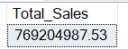
2) Total Units Sold (Total Qty)
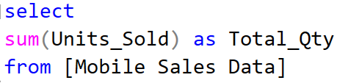
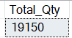
3) Total Transactions
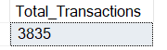
4) YTD Total Sales
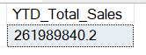

5) YTD Total Units Sold (Qty)
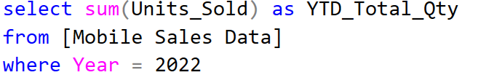
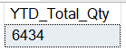
6) YTD Total Transaction
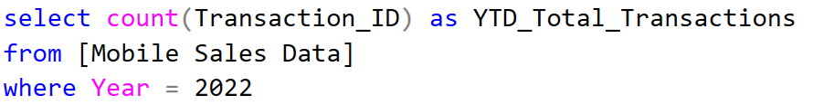
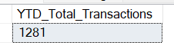
7) MTD Total Sales
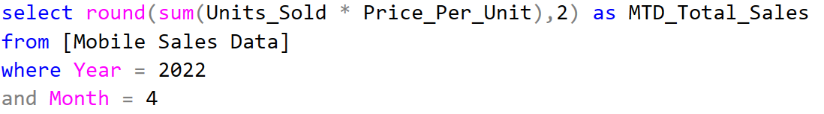
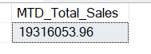
8) MTD Total Units Sold
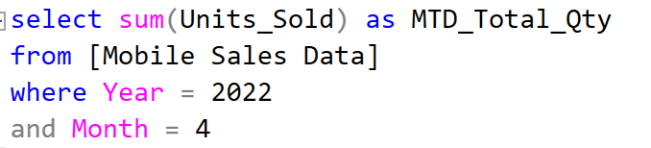

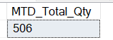
9) MTD Total Transactions
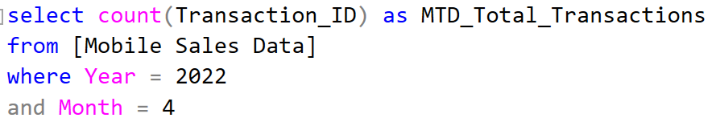
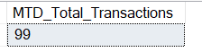
Product:
10) Brand wise Total Sales
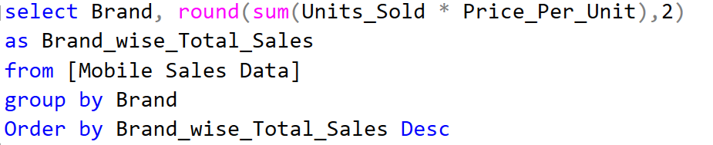
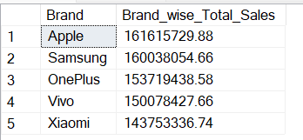
11) Model wise Total Sales
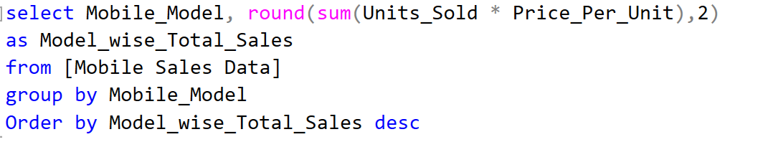
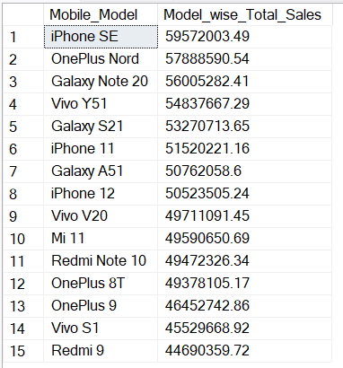
12) Brand and Model wise Total Sales
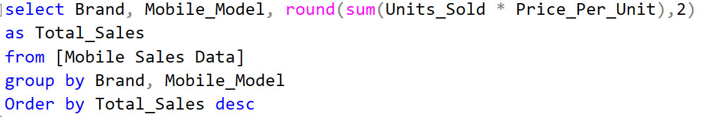
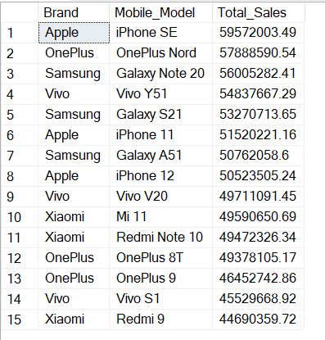
13) Brand wise Total Units Sold
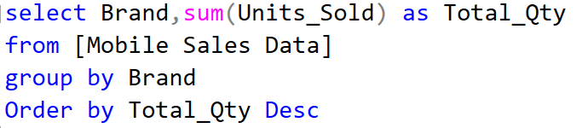
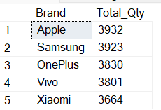
14) Brand and Model wise Total Units Sold
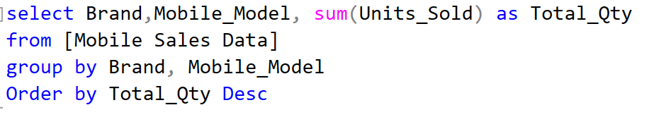
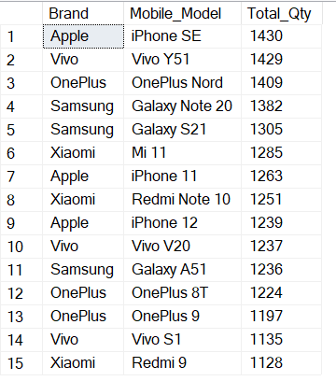
15) Brand wise average customer rating
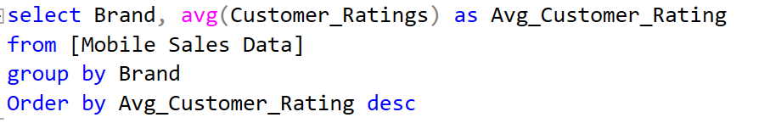
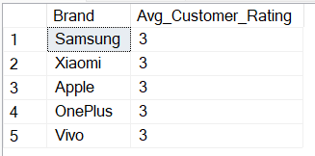
16) Brand wise Total Transactions
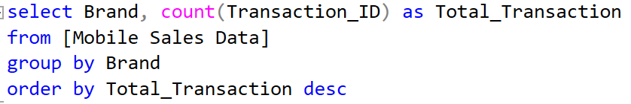
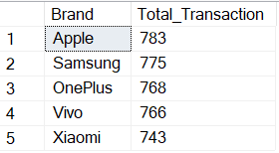
17) Transactions of all Brands by model
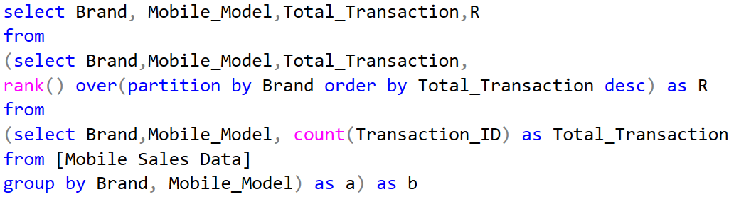
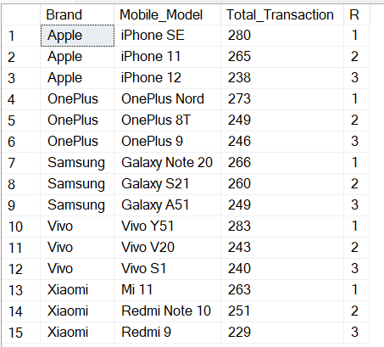
18) Brand and Model wise Top 3 most sold out units
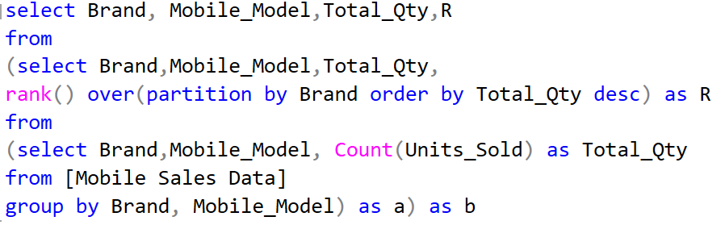
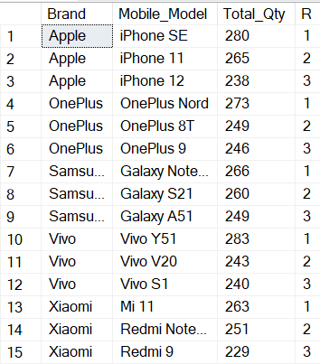
19) Brand and Model wise Top 3 most sold out units with sales
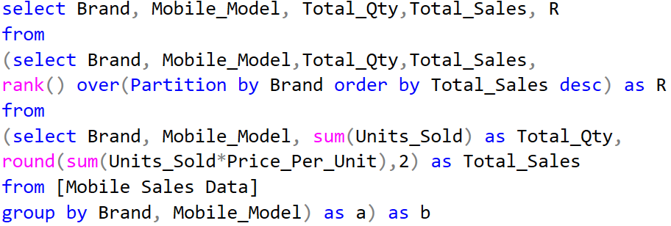
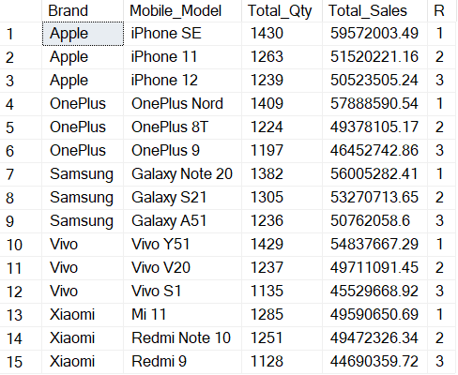
20) Brand and Model wise Top 3 most sold out units with sales and Total Transactions
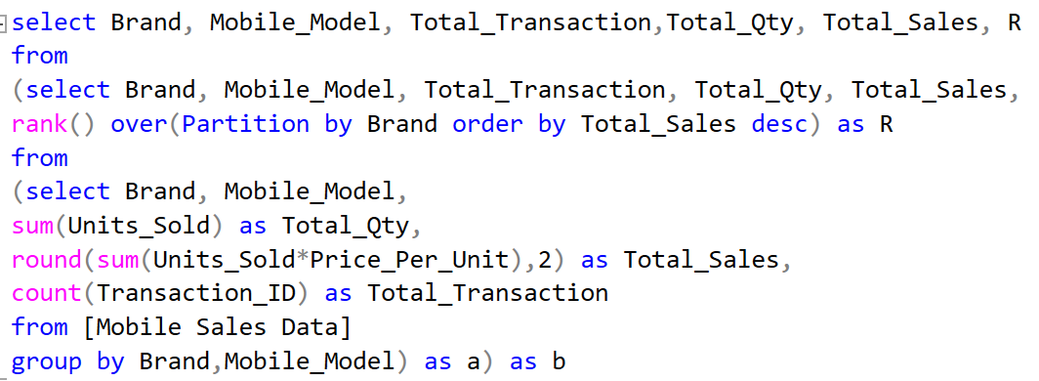
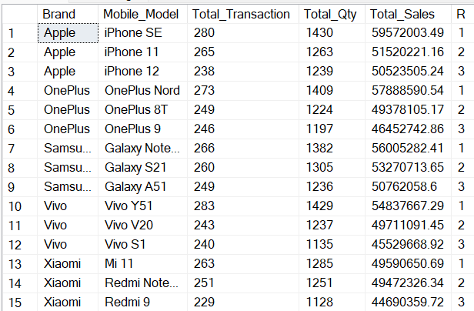
21) Total Transactions by Payment Methods
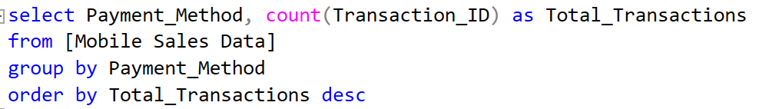
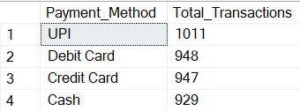
22) Brand and Model wise Total Qty by Payment Methods
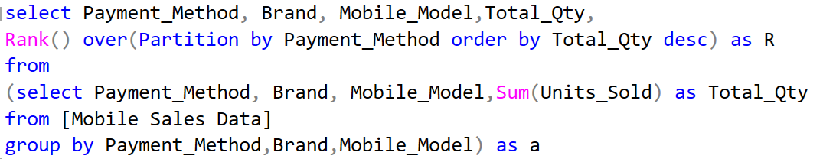
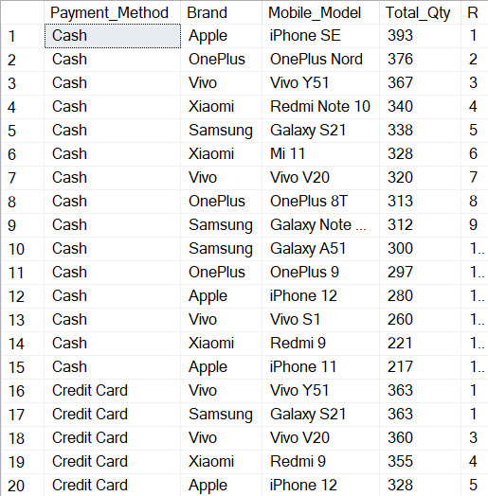
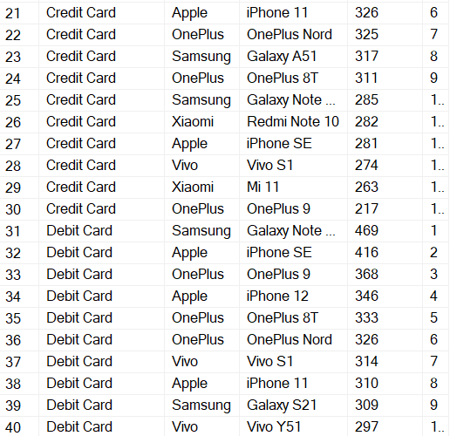
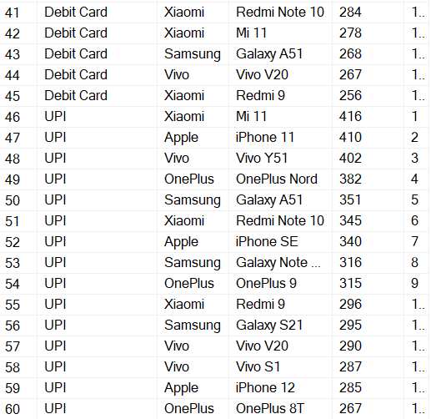
23) Total Sales, Total Qty and Total Transactions by City
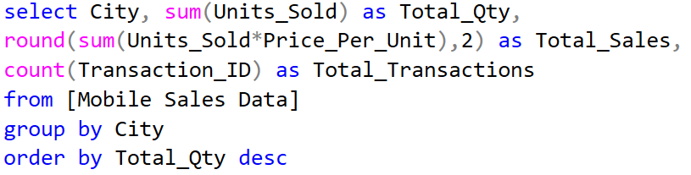
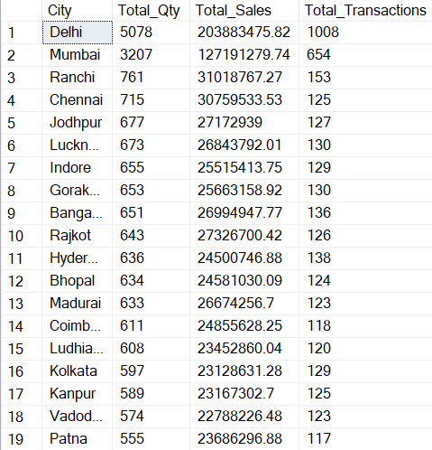
24) Top 2 most sold out units by Brand and City
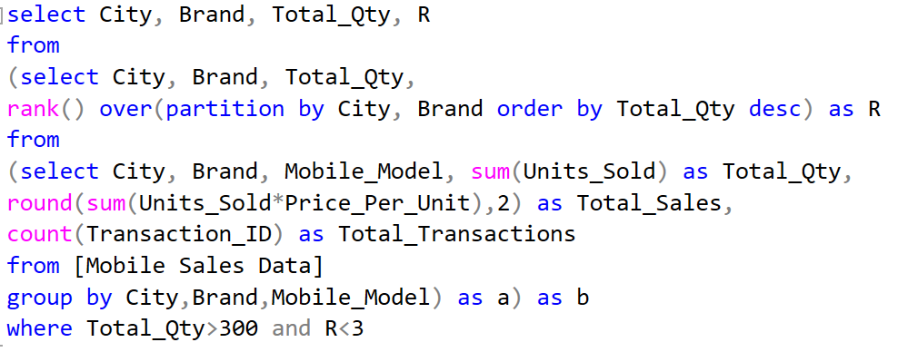
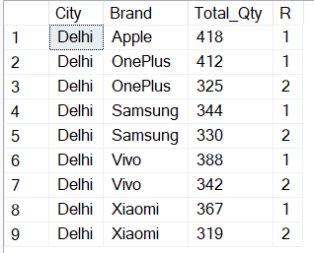
25) Top Cities and Brands with highest revenue
